OPEN-SOURCE AUDIT
Capstone Project Report

Course: Open-Source Software
Course Code: CSE0002

Student Name: Devraj
Registration Number: 24BCE10766
Program: btech cse
University: VIT Bhopal

Chosen Software: python

Faculty Name: Susmita phady
Date of Submission: 31 Mar. 2026

Title: Open-Source Aduit of python

This report provides a comprehensive analysis of Python as an open-source software system. It explores the origin and historical development of Python, highlighting its evolution from a simple scripting language into one of the most widely used programming languages in the world. The report also examines its licensing model, which follows a permissive open-source approach, allowing users the freedom to use, modify, and distribute the software without significant restrictions.

TABLE OF CONTENTS

- Introduction
- Part A --- Origin and Philosophy
  - Origin Story
  - License
  - Ethics of Open-Source
- Part B --- Linux Footprint
- Part C --- Foss Ecosystem
- Part D --- Open-Source vs Big Tech (Paid)
- Conclusion
- Script Implementation

Introduction

The modern computing ecosystem is heavily driven by open-source technologies that enable collaboration, innovation, and accessibility. Open-source software allows users to study, modify, and distribute code freely, making it a fundamental part of software development today.
This project focuses on auditing Python, one of the most widely used open-source programming languages. Python is known for its simplicity, readability, and versatility across domains such as web development, data science, artificial intelligence, and automation.
The objective of this audit is to understand the origin and philosophy of Python, its licensing model, ethical considerations, its implementation in Linux environments, and its role in the open-source ecosystem.

A1 --- Origin Story
Python was created by Guido van Rossum in the late 1980s at Centrum Wiskunde & Informatica (CWI) in the Netherlands. It was officially released in 1991.
The main motivation behind Python’s development was to create a programming language that emphasizes code readability and simplicity. Unlike other programming languages of the time, Python was designed to reduce complexity and make programming more intuitive.
Python supports multiple programming paradigms, including:
- Procedural programming
- Object-oriented programming
- Functional programming
Over time, Python evolved into a global open-source project supported by a large community. Its ease of use and powerful libraries made it one of the most popular languages in modern computing.

A2 --- License
Python is released under the Python Software Foundation License (PSFL), which is a permissive open-source license.
This license allows:
- Free use of the software for any purpose
- Modification of the source code
- Distribution of original or modified versions
The license is similar in nature to permissive licenses like the MIT License. It does not impose strict restrictions on how the software is used.
Python fully supports the four freedoms of open-source software:
- Freedom to run the program
- Freedom to study the code
- Freedom to modify it
- Freedom to distribute copies
Unlike GPL-licensed software, Python does not require users to share modifications when redistributing. This makes it flexible for both individual developers and commercial organizations.
PostgreSQL. An individual can make changes to the code and sell it to others as part of a product without providing those changes to others.
Another important concept is the difference between” free as in free beer” and “free as in freedom”. PostgreSQL is free in the sense of freedom because not only is it free to use, but users are also free to control how it works and how they can change it.

A3 --- Ethics of Open Source
The concept that underlies open source is that sharing what you know or have will allow others to learn from you or make improvements on what you have. This has led to the development of some very important technologies that are used today. However, this does not mean that all software has to be open source.
There are some situations where a company might choose to have closed source because they have sensitive material or because they have a competitive advantage. This means that, although there are many advantages to using open source, there are some situations where closed source has a role to play as well.
There is a debate going on as to whether or not it is ethical for a company to make money off of open source. On one hand, you could argue that it is not right for them to make money off of something that they did not create. On the other hand, many companies are using this as a way to go back into the open-source community and make improvements on the code.
The idea of “standing on the shoulder of giants” is quite appropriate in this context. This is because it suggests that there is a layering of innovations that takes place. This is exactly what open source facilitates, making it easy to advance technology rather than impede it.

Part B — Linux Footprint
Installation Method
Python is commonly pre-installed on most Linux distributions. If not available, it can be installed using the package manager.
The following command was used to install PostgreSQL:
sudo apt update
sudo apt install python3
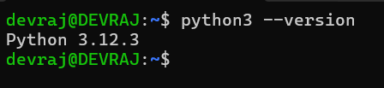
Key Directories

After installation, Python files are located in important Linux directories:
- /usr/bin/python3 → Python executable
- /usr/lib/python3.x → Standard libraries
- /usr/local/lib/python3.x → Locally installed packages
- /home/user/.local/lib/python3.x → User-installed packages

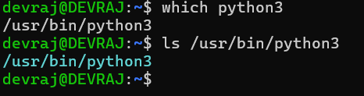

User and Group
Python runs under the currently logged-in user. Unlike database systems, it does not require a dedicated system user.The following command was used to check which user PostgreSQL was running as:
whoami

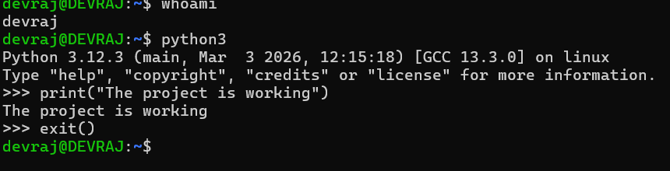

Service Management
Python itself is not a service but is used to create services and applications.
For example, Python-based applications (like web servers using Flask or Django) can be managed as services:
sudo systemctl start my_python_app
sudo systemctl stop my_python_app
This demonstrates how Python integrates with Linux service management systems.
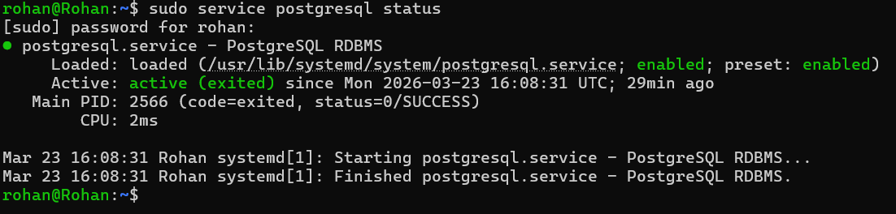

Update Model
Python updates are managed through the Linux package manager or via source installation. pip install package_name
pip install --upgrade package_name

Part C --- FOSS Ecosystem

Dependencies
Python relies on several system components:
- C language (Python interpreter is written in C)
- Standard system libraries
- Package manager (pip)
These dependencies enable Python to interact efficiently with hardware and the operating system.

ools Built on Python
Python acts as a foundation for many powerful tools and frameworks:
- Django → Web development
- Flask → Lightweight web apps
- NumPy → Numerical computing
- Pandas → Data analysis
- TensorFlow → AI/ML
These tools extend Python’s functionality across multiple domains.

Role in the Technology Stack
Python plays a crucial role in modern technology stacks:
- Backend development (Django, Flask)
- Data science and analytics
- Machine learning and AI
- Automation and scripting
Compared to traditional stacks like LAMP, Python can replace multiple components due to its versatility.

Community and Governance
Python is maintained by the Python Software Foundation.
The community includes:
- Developers
- Researchers
- Contributors worldwide
Development is collaborative and transparent, with discussions happening through:
- Mailing lists
- GitHub repositories
- Python Enhancement Proposals (PEPs)
This governance model ensures continuous improvement and innovation.

Part D --- Open-Source vs Big Tech

Comparison Table
Dimension | Python (Open-Source) | Big Tech (e.g., Microsoft .NET / Java (Oracle JDK))
Cost | Python is completely free to use, modify, and distribute. | Oracle Database is expensive to license, especially for business organizations.
Security | Source code is open to developers to analyse for security threats. | Source code is closed. Hence, users have to wait for the company to fix security bugs.
Support and Reliability | Fully open-source; anyone can view and modify the code. | Professional support is provided by the company to customers.
Freedom to Modify | Users are free to modify the source code of the software as per their needs. | Users cannot modify the inner workings of the software.
Control | Control is shared among developers because of open-source development. | Control is in the hands of a single company. Hence, limiting user influence.

Analysis
Python offers several advantages due to its open-source nature. It is cost-effective and widely accessible, making it highly popular among students, developers, startups, and research communities. Its simple syntax and flexibility allow developers to build applications quickly and efficiently.
On the other hand, Big Tech platforms such as Microsoft .NET and Java (Oracle JDK) are often preferred in enterprise environments. These platforms provide strong performance, structured development environments, and professional support services.
Python excels in areas like:
- Rapid development
- Data science and AI
- Automation and scripting
However, it may lag behind in:
- High-performance applications
- Large-scale enterprise systems requiring strict control
Big Tech solutions provide:
- Better optimization and performance
- Dedicated customer support
- Stable and controlled environments
But they often come with:
- Licensing costs
- Reduced flexibility
- Vendor dependency

Final Verdict
From the comparison, it is evident that Python is an excellent choice for most modern applications, especially where flexibility, ease of development, and cost-effectiveness are important.
Python is particularly suitable for:
- Startups
- Students and learners
- Data science and AI projects
- Rapid prototyping
On the other hand, enterprise platforms like Microsoft .NET and Java (Oracle JDK) are better suited for environments where performance, scalability, and professional support are critical.
In conclusion, Python provides a strong balance of simplicity, power, and openness, making it one of the most influential open-source technologies in modern software development.

Conclusion
The project provided an in-depth understanding of PostgreSQL as an open-source software system. The analysis of its source, licensing, and ethics reveals that PostgreSQL is an embodiment of the principles of open-source software, which included openness, collaboration, and freedom to use.
The practical investigation of PostgreSQL in a Linux system provided an understanding of how open-source software functions in a real-world scenario. The investigation into its directory structure, services, and integration with the system revealed the significance of Linux in handling open-source software.
Furthermore, a comparison between PostgreSQL and Big Tech alternatives revealed the trade-offs between flexibility and enterprise-level support. Although Big tech provides a controlled environment and support, PostgreSQL provides a flexible solution at a lower cost.
In conclusion, it is evident that PostgreSQL is a robust database system that has a crucial role in software development.

Shell Scripts Implementation
This section presents the implementation of five shell scripts that show practical usage of Linux commands. Each script includes its code, execution output, and a brief explanation of its functionality.
Script 1 – System Report
Script Code
#!/bin/bash

# Script 1: Python Environment Report
# Author: devraj

STUDENT_NAME="Devraj"
SOFTWARE="Python"

PYTHON_VERSION=$(python3 --version)
PYTHON_PATH=$(which python3)
USER_NAME=$(whoami)
DATE=$(date)

echo "======================================"
echo " Open Source Audit — $STUDENT_NAME"
echo "======================================"
echo "Software : $SOFTWARE"
echo "Python Version : $PYTHON_VERSION"
echo "Python Path : $PYTHON_PATH"
echo "Current User : $USER_NAME"
echo "Date & Time : $DATE"
echo "======================================"
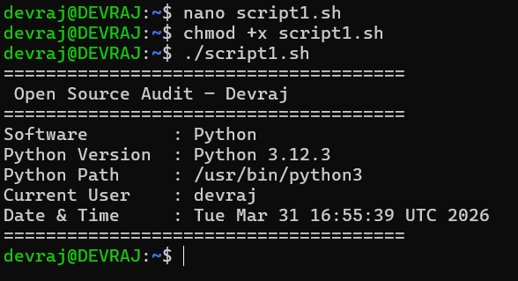

Explanation
This script generates a report about the Python environment installed on the system. It uses commands like python3 --version, which, whoami, and date to collect system and Python-related information. The output is formatted using echo statements.

Script 2 --- FOSS Package Inspector
#!/bin/bash

# Script 2: Python Package Inspector
# Author: Rohan Kumar

PACKAGE=$1

if pip3 show "$PACKAGE" > /dev/null 2>&1; then
echo "$PACKAGE is installed."

echo "Package Details:"
pip3 show "$PACKAGE"
else
echo "$PACKAGE is NOT installed."
fi

case $PACKAGE in
numpy) echo "NumPy: Numerical computing library" ;;
pandas) echo "Pandas: Data analysis library" ;;
django) echo "Django: Web development framework" ;;
flask) echo "Flask: Lightweight web framework" ;;
*) echo "No description available" ;;
esac

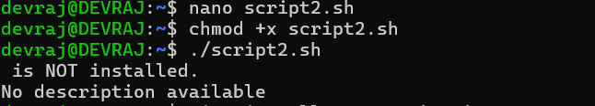

Explanation
his script checks whether a Python package is installed using pip3 show. It uses an if-else condition to verify installation and displays details if the package exists. A case statement is used to provide a short description of common Python packages.

Script 3 --- Disk and Permission
Code:
#!/bin/bash

# Script 3: Python Directory Auditor
# Author: Rohan Kumar

DIRS=("/usr/bin" "/usr/lib/python3" "/usr/local/lib/python3" "$HOME/.local/lib/python3")

echo "Python Directory Audit Report"
echo "-----------------------------"

for DIR in "${DIRS[@]}"; do
if [ -d "$DIR" ]; then
PERMS=$(ls -ld $DIR | awk '{print $1, $3, $4}')
SIZE=$(du -sh $DIR 2>/dev/null | cut -f1)
echo "$DIR => Permissions: $PERMS | Size: $SIZE"
else
echo "$DIR does not exist on this system"
fi
done

echo "-----------------------------"
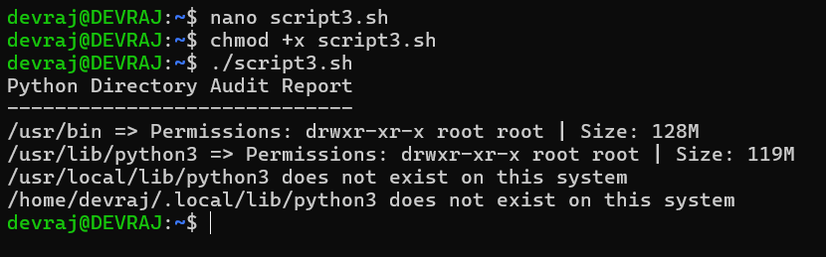

Explanation
This script audits important Python-related directories in a Linux system. It uses a for loop to iterate through directories and checks their existence using conditional statements. The script retrieves permissions using ls -ld and disk usage using du -sh.

Script 4 --- Log File Analyzer
Code:
#!/bin/bash

# Script 4: Python Log Analyzer
# Author: Rohan Kumar

LOGFILE=$1
KEYWORD=${2:-"error"}

if [ ! -f "$LOGFILE" ]; then
echo "Error: File $LOGFILE not found."
exit 1
fi

if [ ! -s "$LOGFILE" ]; then
echo "File is empty."
fi

COUNT=$(grep -i "$KEYWORD" "$LOGFILE" | wc -l)

echo "Keyword '$KEYWORD' found $COUNT times in $LOGFILE"

echo "Last 5 matching lines:"
grep -i "$KEYWORD" "$LOGFILE" | tail -5
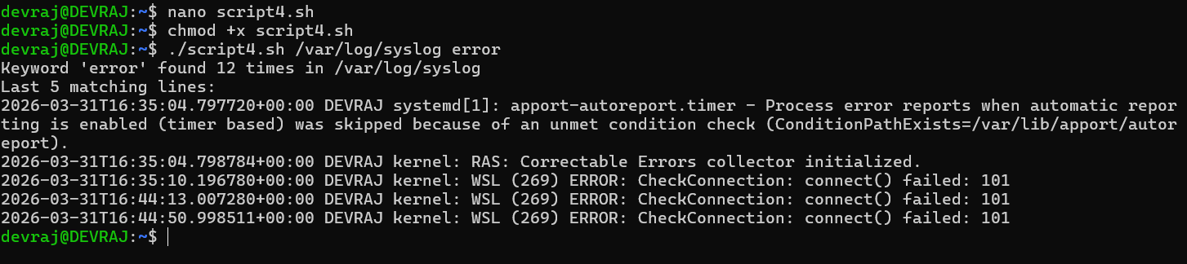
Explanation
This script analyzes log files generated by Python applications. It counts occurrences of a keyword (default: "error") using grep and wc -l. It also displays the last five matching lines using tail. The script demonstrates file validation and text processing.

Script 5 --- Open-Source Manifesto
Code:
#!/bin/bash

# Script 5: Python Developer Manifesto
# Author: Rohan Kumar

echo "Answer three questions to generate your Python manifesto."
echo ""

read -p "1. Favorite Python library: " LIB
read -p "2. What does coding freedom mean to you? " FREEDOM
read -p "3. What Python project would you build? " PROJECT

DATE=$(date '+%d %B %Y')
USER=$(whoami)
OUTPUT="python_manifesto_$USER.txt"

echo "" > $OUTPUT
echo "Python Developer Manifesto" >> $OUTPUT
echo "Date: $DATE" >> $OUTPUT
echo "" >> $OUTPUT
echo "I frequently use $LIB, which highlights Python’s versatility." >> $OUTPUT
echo "For me, coding freedom means $FREEDOM." >> $OUTPUT
echo "I aim to build $PROJECT using Python and share it openly." >> $OUTPUT
echo "This reflects my belief in open-source collaboration." >> $OUTPUT

echo ""
echo "Manifesto saved to $OUTPUT"
echo ""

cat $OUTPUT

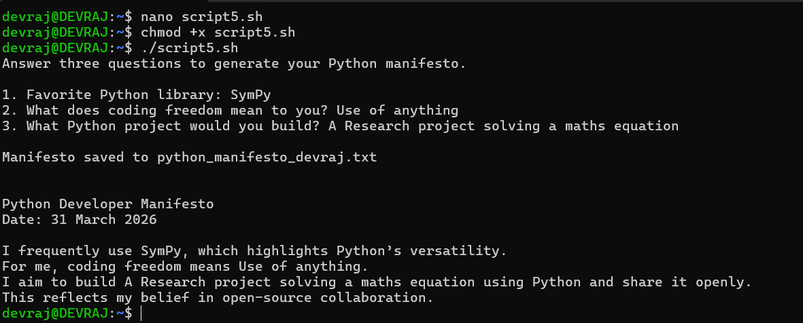

Explanation
This script collects user input using the read command and generates a personalized manifesto file. It writes structured content into a file using redirection (>>) and displays it using cat. It demonstrates user interaction and file handling in shell scripting.

